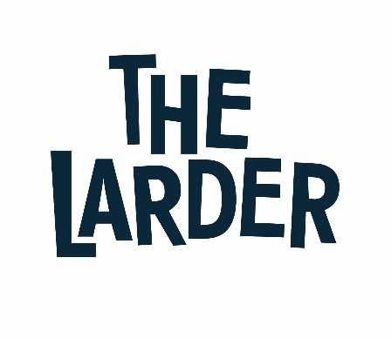

Job Title: Self Employed Barista Trainer
Organisation: The Larder West Lothian
Reports to: Training Manager
Salary: £15 per hour
Contract: Self Employed

Summary and main purpose of role:

Are you a superstar Barista who not only loves the hustle and bustle of coffee shops, but someone who is a great communicator and would love to share their skills and passion with young people and adults? Well we have the perfect role for you!
The Larder’s vision is for a Scotland where everyone has the opportunity to reach their full potential regardless of the start that they have had in life. We use our social enterprise to enable young people and adults, who have multiple complex barriers to reaching their full potential, to engage in learning that meets their needs and aspirations.
To enable us to support our growth we are now recruiting for a self-employed Barista Trainer who can provide training to learners who are 14+ year olds either at school or on an employability or Individual Training Account (ITA) course.
The courses will develop the learner’s knowledge, understanding and technical skills required for the role of a barista in the future and help them towards employment.
You will be invited to deliver specific contracts as they are awarded to The Larder or to provide staff cover during sickness and holidays, as well as supporting our operations where necessary.
Hours of work, delivery and payment will be agreed with the Training Manager in advance of the start of each contract.
As a member of The Larder team, you will be a positive role model and engage with our trainees in a friendly and professional manner. You will be reliable, enthusiastic and remain consistent with our company values. You will have great communication skills, a friendly and engaging personality and a committed team player.

This role is self-employed and may require you to work flexibly across our different locations.

Some of the key aspects of a contract could include:
- Lead by example to ensure the learner journey is positive, including front line delivery
- Provide all round support to learners in developing their knowledge and skills and helping them to access appropriate further training
- Ensure professionalism to include daily checks on the learning environment, session preparation, ensuring learners are effectively engaged in learning
- Set targets for learner’s participation, retention, achievement and progression
- Monitor learner’s performance according to agreed standards and targets and take necessary action to support and resolve according to performance levels.

All associate staff will be expected to demonstrate strong leadership skills and be willing and able to:
- Communicate, promote and implement The Larder Equality and Diversity policy
- Promote and implement safe working practices in line with The Larder Health and Safety policies
- Inspire, encourage, empower and promote innovation and share best practice with colleagues and learners

As an associate you will be responsible for:
- Managing your own time, tax and national insurance
- Submitting invoices for the work delivered as agreed in each contract
- Provide evidence of continuous professional development in line SQA requirements

In return The Larder will:
- Pay all invoices in the agreed timescales
- Add you to our newsletter mailing list so that you are engaged in all of our contracts
- Include you in relevant training and team events to ensure that you are informed of all developments in the organisation
- Invite you to stakeholder events

This role requires the post holder to have a PVG Scheme membership/record. If the post holder is not a current PVG member for the required regulatory group (i.e. Child and/or adult) then an application will need to be made to Disclosure Scotland and deemed satisfactory before they can begin in post.

To apply please send your CV and covering letter to:
Jane Deary, Director of Strategy and People at hr@thelarder.org
The covering letter should be no more than one A4 side and should set out why you want to work with the Larder and expand on the specific skills that you would bring to the post.

Person Specification

 | Essential | Desirable | Method of assessment
Qualifications/ Training:
L&D9DI SQA Assessor qualification (or equivalent) |  |  | Application Form and Interview
Train the trainer/Barista certified |  |  | Application Form and Interview
Experience
Worked as a Barista for 2+ years |  |  | Application Form and Interview
Comfortable training Young People and Adults to a standard expected as a Barista |  |  | Application Form and Interview
Skills and Knowledge:
Able to work within a team and on own initiative |  |  | Application Form and Interview
Excellent communication, interpersonal and customer service skills |  |  | Application Form and Interview
Attributes / Other Requirements:
Demonstrates enthusiasm, confidence and pride in yourself and others’ abilities and bring out the best in others |  |  | Application Form and Interview
Have an excellent work ethic and pays attention to detail |  |  | Application Form and Interview
Self-motivated and proactive with the ability to use initiative and take responsibility |  |  | Application Form and Interview

