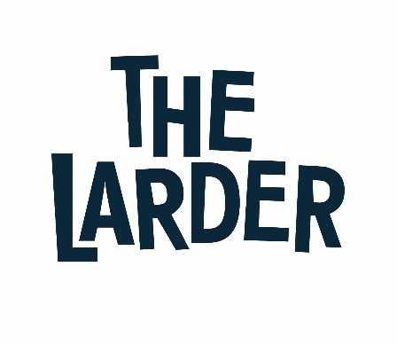

Job Title: Catering Assistant
Organisation: The Larder West Lothian
Reports to: Hospitality Lead
Salary: Living Wage

Summary and main purpose of role:
Our Catering Assistants contribute to the Larder’s success by providing excellent customer service to all our customers throughout our café locations and bakery. If you are a person who enjoys working with the public, providing an excellent level of customer service at all times and having fun, then we would love to hear from you!

As a member of The Larder team you will be a positive role model and engage with our trainees and customers in a friendly and professional manner. You will be reliable, enthusiastic and remain consistent with our company values. You will have great communication skills, a friendly and engaging personality and a committed team player.

This may require you to work flexibly across our café and bakery locations in West Lothian, working hours to be negotiated.

Key responsibilities for the role include:
- Assist in the preparation of our café counters before, during and at the end of service
- Serving customers with a smile ensuring they walk away happy with an enjoyable experience
- Serving espresso coffee and teas, alongside other hot and cold beverages
- Support the Hospitality Lead in preparing food items for the day
- Monitoring the online ordering app ensuring orders are complete in a timely manner
- Keep up to date with special promotions and create displays
- Be knowledgeable about our products and services
- Operate the till and handle cash/card transactions
- Keep all areas clean and tidy including customer areas
- Follow food safety procedures and keep records up to date
- Undertake all cleaning rotas in the café, kitchen and related areas
- Respond promptly and professionally to any customer feedback, comments or complaints
- Have fun, learn, develop and meet some amazing people

Managing Self:
- Maintains a calm demeanour during periods of high volume or unusual events to ensure café and bakery is operating to standard and set a positive example for others
- Work with the Hospitality Lead to put in place a CPD plan. Take ownership of the CPD plan and ensure that it is implemented and regularly reviewed
- Work closely with colleagues to ensure full use of available skill sets
- Undertake other duties that may be required to ensure effective and efficient operation of the café/bakery.

Standard Responsibilities for all positions in The Larder:

- Participate in any staff review/performance management processes involving the identifying and meeting of training needs for self and others.
- Take appropriate responsibility to ensure the health and safety of self and others.
- Pursue the achievement and integration of equal opportunities throughout all activities.
- Undertake any other tasks and responsibilities appropriate to the level of this post.
- Comply with all Larder policies and procedures
- The Larder is committed to safeguarding and promoting the welfare of children, young people and vulnerable adults and expects all staff to share and promote this commitment.
Benefits Include:
- Company pension contribution of 3% (currently under review)
- 29 days’ annual leave (pro rata for part time staff)
- 2 staff wellbeing days each year
- Access to company health and wellbeing support
- Commitment to continued professional development
All Larder staff are required to apply for a PVG disclosure as you may be asked to be in sole charge of vulnerable children, young people or adults. A disclosure is an impartial and confidential document that details an individual’s criminal record and where appropriate gives details of those who are banned from working with children.

Person Specification

 | Essential | Desirable | Method of assessment
Qualifications/ Training:
Barista Training |  |  | Application Form and Interview
Food Hygiene Certificate |  |  | Application Form and Interview
Experience
Experience working in front of house positions |  |  | Application Form and Interview
Experience of food preparation |  |  | Application Form and Interview
Cash handling experience |  |  | Application Form and Interview
Skills and Knowledge:
Able to work within a team and on own initiative |  |  | Application Form and Interview
Excellent communication, interpersonal and customer service skills |  |  | Application Form and Interview
Attributes / Other Requirements:
Demonstrates enthusiasm, confidence and pride in yourself and others’ abilities and bring out the best in others |  |  | Application Form and Interview
Have an excellent work ethic and pays attention to detail |  |  | Application Form and Interview
Self-motivated and proactive with the ability to use initiative and take responsibility |  |  | Application Form and Interview

